

Pune District Education Association’s
Prof. Ramkrishna More Arts, Commerce, Science College
(Autonomous), Akurdi, Pune - 411044

SAVITRIBAI PHULE PUNE UNIVERSITY
2024 - 2025
A PROJECT REPORT ON

“ DUPLICATE FILE REMOVER ”

Submitted By :
Shaikh Sohail Chand (Roll no : 71229)
Shinde Pratik Chandrakant (Roll no : 71226)
Rasal Dipak Barku (Roll no : 71228)

CLASS

TYBCA(Science) 2024-2025

Under Guidance : Ms. Buchade M.R.
P.D.E.A’s
Prof. Ramkrishna More Arts, Commerce & Science
College (Autonomous)
Akurdi, Pune-411044
CERTIFICATE

This is to certify that Project entitled
Duplicate File Remover
has successfully completed the practical assignments for Lab course
BCA - 368 DSE VI Project Lab
Name of the Students :
1.Shaikh Sohail Chand 71229
2.Shinde Pratik Chandrakant 71226
3.Rasal Dipak Barku 71228
Towards the fulfillment by TYBCA (Science)
2024-2025

Ms. Buchade M. R Ms. More A. R
Project Guide H.O.D
Internal Examiner External Examiner
INDEX

Sr. No. | Title | Page No.
1 | Acknowledgement | 4
2 | Introduction | 5
3 | Requirement Specification  - Hardware  - Software | 6
4 | System Design Details | 7
5 | Results | 8
6 | Future Scope | 11
7 | Conclusion | 12
8 | References | 13

ACKNOWLEDGEMENT
I Sincerely wish to express deep sense of gratitude to my project guide Ms.Manali Buchade Mam and Head of Department Ms. Anuradha More Mam for supporting and guiding me in this project.
I would also like to extend my sincere thanks to all teachers of department for their excellent Guidance and helpful suggestions. I would also like to thanks them for their valuable inspiration and their co-operation during the project work and also thank them for providing us all required facilities.
With thanks from,
- Sohail Chand Shaikh (71229)
- Pratik Chandrakant Shinde (71226)
- Dipak Barku Rasal (71228)

INTRODUCTION

The Duplicate File Remover is an essential tool designed to help users identify and eliminate duplicate files from their computers or storage devices. As digital storage becomes increasingly cluttered with redundant files, this tool offers a streamlined solution to free up valuable disk space, enhance system performance, and improve overall file organization.
Duplicate File Remover is particularly useful for users who manage large volumes of data, such as photos, documents, and more. By scanning folders and detecting duplicates, it ensures that only necessary files are retained, thereby optimizing storage efficiency. The tool is equipped with user-friendly features that make the process of removing duplicates quick and hassle-free.

Features:
- Scan Folders for Duplicates: Easily scan selected directories to identify duplicate files.
- Delete Duplicates with a Single Click: Remove unnecessary duplicates effortlessly with just one click.
- Save Deletion History in JSON Format: Keep a record of deleted files in JSON format for future reference and tracking.
REQUIREMENT SPECIFICATION

Hardware Requirement:
Processor | Intel Core i3 7th Generation
Processor Speed | 2.30 GHz
RAM | 2 GB
System Type | 32bit & 64 bit - Operating System

Software Requirement:
Operating System | Any equivalent OS
Language | Java
Database | JSON format

System Design Details
- ER-Diagram :

User
Stores Deleted files in
Logs

History Logs (JSON)
Contains Files
Select Path
Duplicate Files

Detects
Scans Process
Scans

Folder
Deletion Process
File
Selects

Deletes
RESULTS:
Interface :
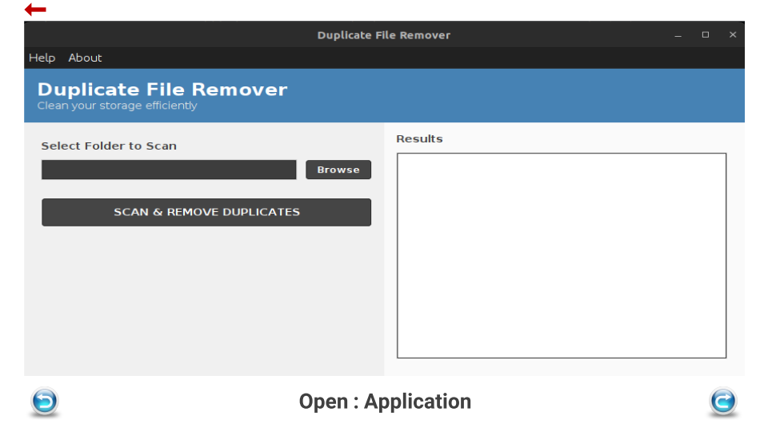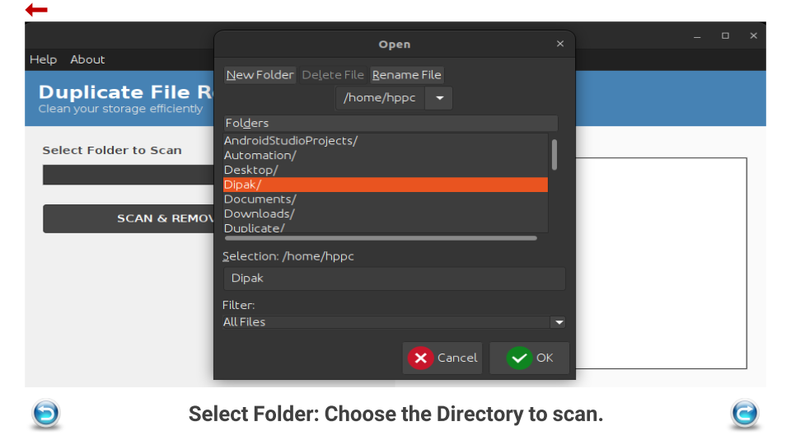
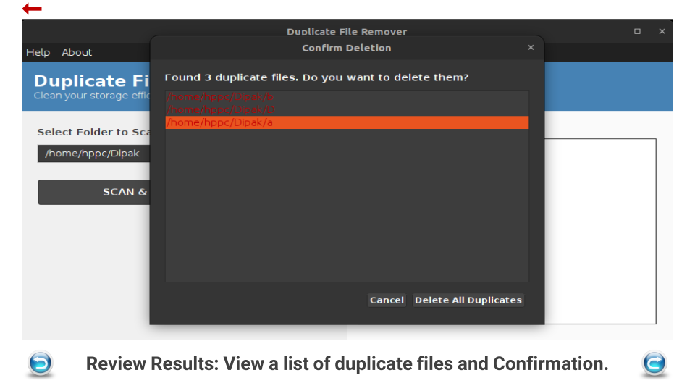
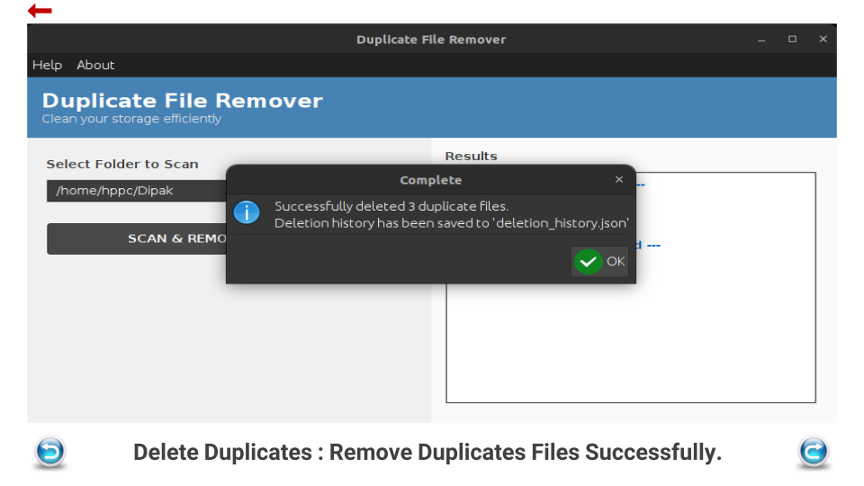

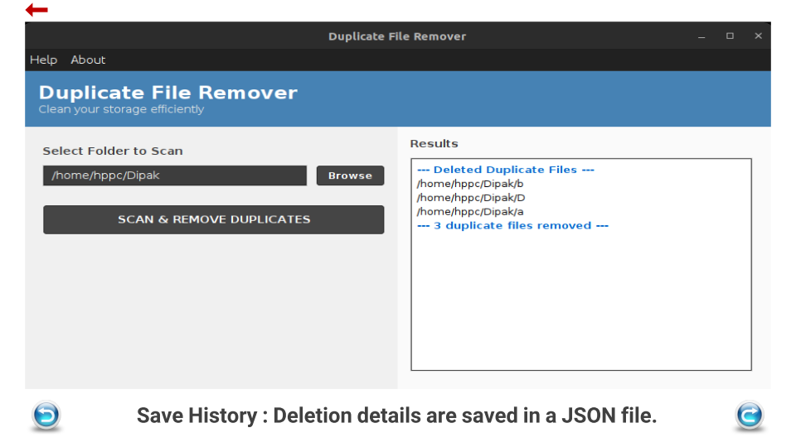
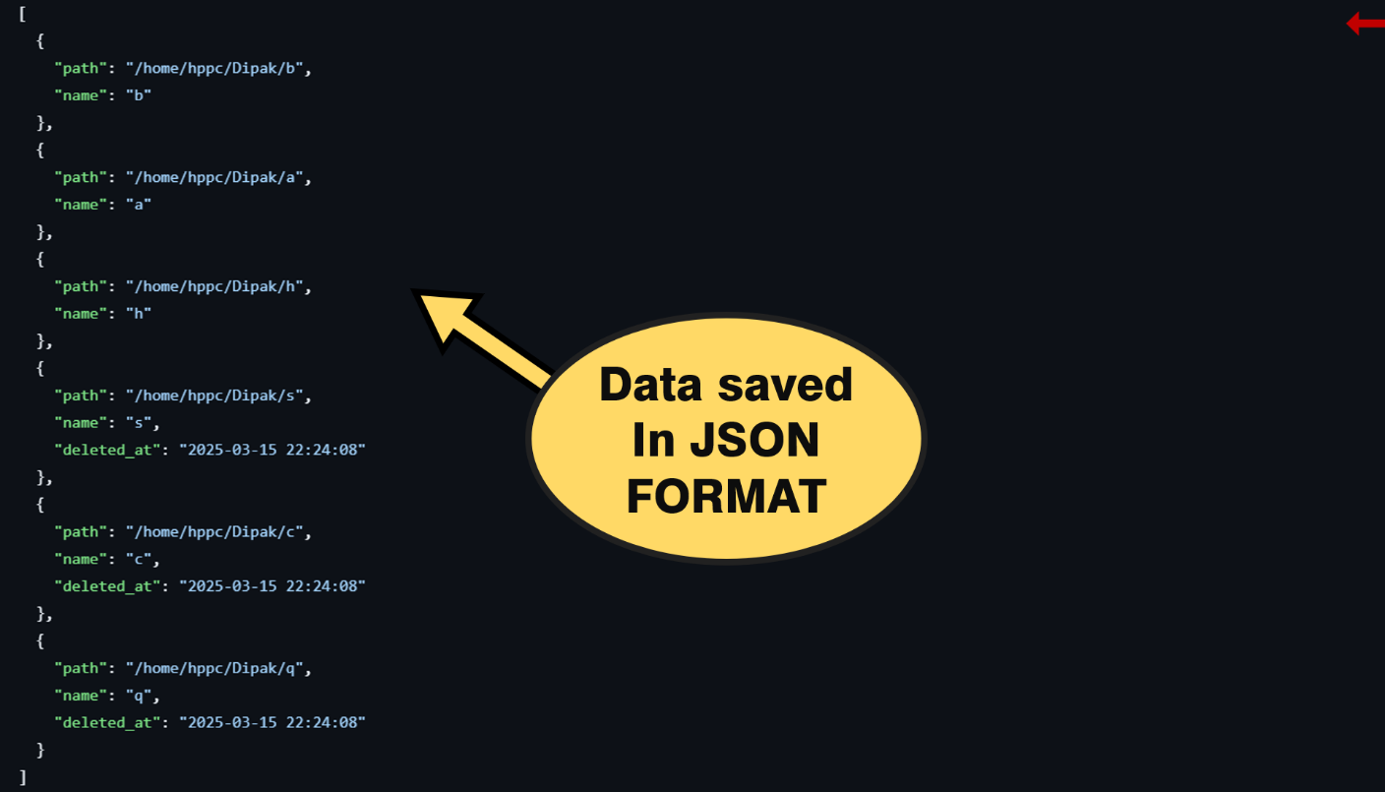

Future Scope:
The Duplicate File Remover has immense potential for growth and enhancement to cater to evolving user needs and technological advancements. Here are some key areas for future development:

- Cloud Integration: Expand functionality to include cloud storage platforms such as Google Drive and Dropbox, allowing users to identify and remove duplicates across both local and cloud-based files seamlessly.

- Advanced Filters: Implement advanced filtering options, enabling users to sort duplicates by file type, size, date modified, or other specific criteria, providing greater control over the file management process.

Conclusion:
The Duplicate File Remover is a powerful and versatile tool designed to help users efficiently manage their storage by identifying and eliminating unnecessary duplicate files. Available as both a desktop application and a web interface, it offers flexibility and convenience for users across different platforms. By freeing up disk space and improving system performance, this tool ensures a more organized and optimized digital environment. Try the Duplicate File Remover today to experience the benefits of a cleaner, faster, and more efficient system!

References:
- GitHub : https://github.com/ShubhamRasal/18-Duplicate-File-Remover/tree/master
- Java : https://docs.oracle.com/javase/tutorial/
- Database : https://www.geeksforgeeks.org/json/

